Multi-Area OSPF Routing Configuration

In this lab, we will create an IPv4 addressing scheme and implement multi-area OSPF routing. The topology is shown in the figure below. You can download the base topology from Canvas to start your configuration.

There are two main areas. Area 1 and Area 51. 
In area 1 there are R1, R3, R4, R5, SW1, PC-1 through PC-7.
In area 51 there are R2, R6, R7, R8, SW2, PC-8 through PC-14.
Here is a description of the network topology for area 1.
R1 is connected to SW1 via e1/0 and R2 via s2/0.
R3 is connected to SW1 via e1/0, PC-1 via e0/0 and PC-2 via e0/1
R4 is connected to SW1 via e1/0, PC-3 via e0/0, PC-4 via e0/1 and PC-5 via e0/2
R5 is connected to SW1 via e1/0, PC-6 via e0/0 and PC-7 via e0/1
Here is a description of the network topology for area 51.
R2 is connected to SW2 via e1/0 and R1 via s2/0.
R6 is connected to SW2 via e1/0, PC-13 via e0/0 and PC-14 via e0/1
R7 is connected to SW2 via e1/0, PC-11 via e0/0 and PC-12 via e0/1
R8 is connected to SW2 via e1/0, PC-8 via e0/0, PC-9 via e0/1, and PC-10 via e0/2
All the PC’s are connected to their respective routers via e0 interface on the PC


The VPCS in the topology are to represent multiple hosts. We will only implement one; however, the subnetting for that network must support the specified number of hosts.

The actual configuration of multi-area OSPF isn’t significantly different than a single area OSPF. However, unlike single area OSPF we have to give more thought to the addressing scheme we use to make the summarization as efficient as possible. We want to minimize the type 3 LSA’s that have to be exchanged between the area border routers (ABR’s).

1. Design an IPv4 addressing scheme of the lab topology that minimizes the number of type 3 LSA’s exchanged between the ABR’s. To do this effectively, we want the subnets in Area 1 to be contiguous (one right after the other) as well as in Area 51.
   1. Draw the addressing from the 10.X.X.X/8 IPv4 address range for the subnets in Area 1 and Area 51.
   2. Use the subnet 192.168.1.0/30 for the serial link between R1 and R2.
   3. Design each network to support the hosts specified below by completing the table.

|  |  |  |  |  |  |  |  |  |
| --- | --- | --- | --- | --- | --- | --- | --- | --- |
| **VPCS #** | **Area** | **Hosts Required** | **Host bits required** | **Network Address** | **1st Host Address** | **Last Host Address** | **Broadcast Address** | **CIDR (/XX)** |
| 1 | 1 | 228 |  |  |  |  |  |  |
| 2 | 1 | 899 |  |  |  |  |  |  |
| 3 | 1 | 135 |  |  |  |  |  |  |
| 4 | 1 | 646 |  |  |  |  |  |  |
| 5 | 1 | 152 |  |  |  |  |  |  |
| 6 | 1 | 118 |  |  |  |  |  |  |
| 7 | 1 | 510 |  |  |  |  |  |  |
| 8 | 51 | 564 |  |  |  |  |  |  |
| 9 | 51 | 601 |  |  |  |  |  |  |
| 10 | 51 | 293 |  |  |  |  |  |  |
| 11 | 51 | 665 |  |  |  |  |  |  |
| 12 | 51 | 185 |  |  |  |  |  |  |
| 13 | 51 | 155 |  |  |  |  |  |  |
| 14 | 51 | 204 |  |  |  |  |  |  |

This table is available for download on Canvas as an Excel file.

A technique to make the design easier starts with the largest subnets first and work to the smaller subnets. Also, if any require less than 24 bits, allocate 24 bits to that subnet. One final thought on the design if you are close to a bit boundary in your subnets in one area. For example, if you have 10.0.0.0 through 10.0.13.255 allocated to subnets in one area, you might want to over-allocate to one of your bigger subnets to make the ranges in the area 10.0.0.0 through 10.0.15.255 because now it can be summarized as 10.0.0.0/20. Compare this to not over-allocating, and we end up with Type 3 LSA’s of 10.0.0.0/21, 10.0.8.0/22, and 10.0.12.0/23.

**Q1: Are there any instances in your network design that would benefit from over-allocation to a subnet to reduce the number of summarization messages (type 3 LSA’s) sent?**

1. Implement your network design in the topology. Allocate the 1st host address of the subnet to the router interface and the last host address of the subnet to the VPCS. Don’t forget when setting the IP address on the VPCS to also set the gateway, which should be the IP address of the router. The format of the command for the VPCS is

**ip address subnet gateway**

1. Verify your network configuration with some pings between the router interfaces that are directly connected.
2. Implement OSPF multi-area routing.
   1. Implement OSPF in area 1 and get it working – Only between the hosts in area 1.
   2. Implement OSPF in area 51 and get it working – Only be the hosts in area 51
   3. Implement OSPF on area border routers with area 0. Area 0 is the backbone area.
3. Verify that routing is working across the areas.

**Q2: Which routers are the area border routers?**

R1 and R2 are ABRs

**Q3: On a router in area 1 and a router in area 51 do the command show ip ospf route Are the routes summarized to the other area? Why or why not?**

No, the routes are not. The routes are only summarized for the areas they belong in.

**Q4: To enable summarization, we need to be on the area border routers and issue the following commands.**

**router ospf X**

**area 1 range network_address subnet_mask**

**area 51 range network_address subnet_mask**

**What commands did you issue on each of the area, routers?**

**Area 1 range 10.0.0.0 255.255.224.0**

**Area 51 range 10.51.0.0 255.255.224.0**

**Q5: On a router in area 1 and a router in area 51 do the command show ip ospf route Are the routes now summarized to the other area? Why or why not?**

**Yes they are, the routes are showing in the OSPF database.**

**Q6: On R1 and R2 do a show ip ospf database and paste a screenshot of the command in the document for the answer to this question. Are all the networks in the topology present in that ospf database?**

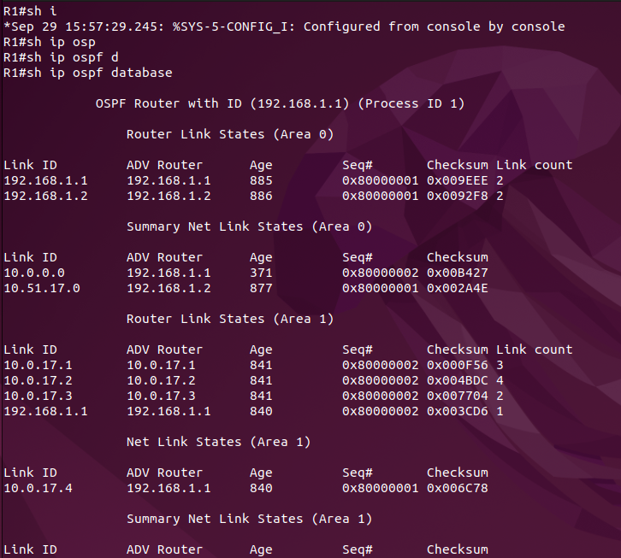

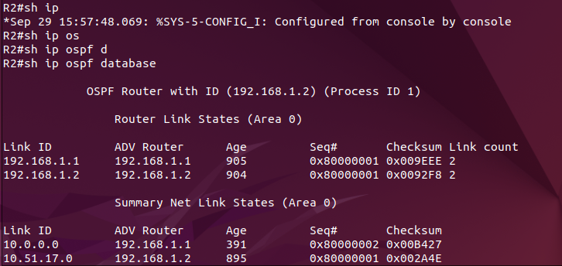

Export your working topology to a GNS3 portable project and upload your file to along with the answers to these questions.